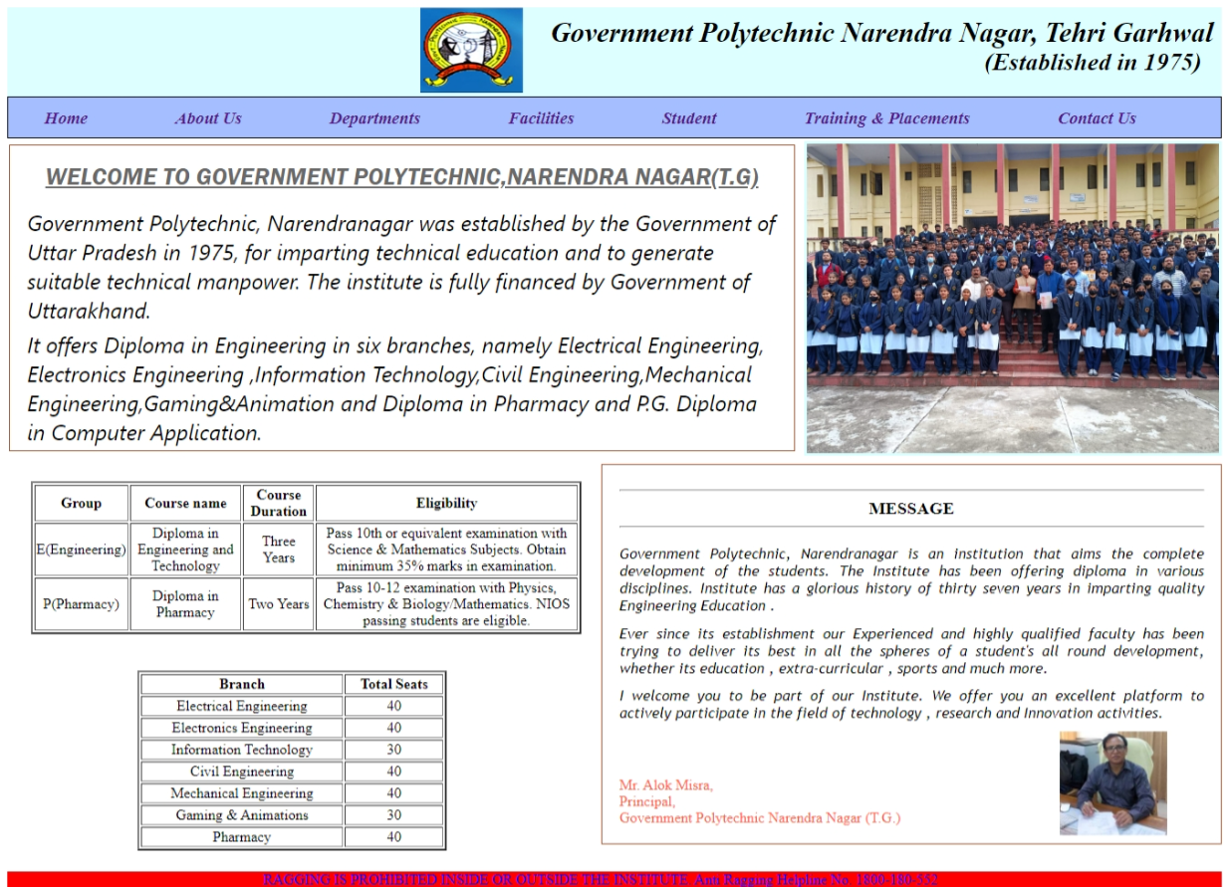

**Lab Practical - 10**

|  |
| --- |
| **Aim:** Design a single page website for your polytechnic containing a description of the courses offered. It should also contain some general information about the college such as its history, the campus, and its unique features and so on. The site should be colored and each section should have a different color.  **Hardware Requirements: Software Requirements:**  Desktop with at least 1 GB RAM and Notepad or Visual Studio Code or  500 MB free disk space any other Text Editor & a Web  Browser  **Practical 10.html**  <! DOCTYPE html>  <html lang="en">  <head>  <title>Government Polytechnic Narendra Nagar Tehri Garhwal Uttarakhand</title>  <link rel="icon" href="unnamed.jpg" type="image/icon type">  <link rel="stylesheet" href="webstyle.css">  </head>  <body>  <div id="hdo">  <img id="hdimage" src="1438534.png" alt="img">  <div id="hdi1">Government Polytechnic Narendra Nagar, Tehri Garhwal</div>  <div id="hdi2"> (Established in 1975) </div>  </div>  <nav id="menu">  <ul>  <li><a href="#">Home</a></li>  <li><a href="#">About Us</a></li>  <li><a href="#">Departments</a></li>  <li><a href="#">Facilities</a></li>  <li><a href="#">Student</a></li>  <li><a href="#">Training & Placements</a></li>  <li><a href="#">Contact Us</a></li>  </ul>  </nav>  <img src="clgimg.jpg" alt="img" id="image">  <div id="welcome">  <div id="wel">WELCOME TO GOVERNMENT POLYTECHNIC,NARENDRA NAGAR(T.G)</div>  <div id="info">Government Polytechnic, Narendranagar was established by the Government of Uttar Pradesh in  1975, for imparting technical education and to generate suitable technical manpower. The institute is fully  financed by Government of Uttarakhand.  </div>  <div id="info">It offers Diploma in Engineering in six branches, namely Electrical Engineering, Electronics  Engineering ,Information Technology,Civil Engineering,Mechanical Engineering,Gaming&Animation and Diploma in  Pharmacy and P.G. Diploma in Computer Application.  </div>  </div>  <div id="message">  <hr>  <div class="mes">MESSAGE</div>  <hr>  <div class="message1">Government Polytechnic, Narendranagar is an institution that aims the complete development of the students.  The Institute has been offering diploma in various disciplines. Institute has a glorious history of thirty  seven years in imparting quality Engineering Education .  </div>  <div class="message1"> Ever since its establishment our Experienced and highly qualified faculty has been trying  to deliver its  best in all the spheres of a student's all round development, whether its education , extra-curricular ,  sports and much more.  </div>  <div class="message1">I welcome you to be part of our Institute. We offer you an excellent platform to actively  participate in the  field of technology , research and Innovation activities.  </div>  <img src="principal.jpg" alt="img" id="principal">  <div class="mes1">Mr. Alok Misra,<br>  Principal,<br>  Government Polytechnic Narendra Nagar (T.G.)  </div>  </div>  <table border="+2" id="course">  <tr>  <th>Group</th>  <th>Course name</th>  <th>Course Duration</th>  <th>Eligibility</th>  </tr>  <tr>  <td>E(Engineering)</td>  <td>Diploma in Engineering and Technology</td>  <td>Three Years</td>  <td>Pass 10th or equivalent examination with Science & Mathematics Subjects. Obtain minimum 35% marks in  examination.</td>  </tr>  <tr>  <td>P(Pharmacy)</td>  <td>Diploma in Pharmacy</td>  <td>Two Years</td>  <td>Pass 10-12 examination with Physics, Chemistry & Biology/Mathematics. NIOS passing students are  eligible.</td>  </tr>  </table>  <table border="+2" id="seats">  <tr>  <th>Branch</th>  <th>Total Seats</th>  </tr>  <tr>  <td>Electrical Engineering</td>  <td>40</td>  </tr>  <tr>  <td>Electronics Engineering</td>  <td>40</td>  </tr>  <tr>  <td>Information Technology</td>  <td>30</td>  </tr>  <tr>  <td>Civil Engineering</td>  <td>40</td>  </tr>  <tr>  <td>Mechanical Engineering</td>  <td>40</td>  </tr>  <tr>  <td>Gaming & Animations</td>  <td>30</td>  </tr>  <tr>  <td>Pharmacy</td>  <td>40</td>  </tr>  </table>  <marquee id="ft" behavior="alternate" direction="left" loop="">  <div>RAGGING IS PROHIBITED INSIDE OR OUTSIDE THE INSTITUTE. Anti Ragging Helpline No. 1800- 180-552</div>  </marquee>  </body>  </html>  **Webstyle.css**  body{  background-color:rgb(255 255 255);  }  #hdo{  background-color: rgb(222, 255, 255);  }  #hdimage{  height: 2.5cm;  position: relative;  left: 12cm;  }  #hdi1{  position: absolute;  left: 16cm;  top: 0.5cm;  font-size: 0.81cm;  font-style: oblique;  font-weight: 600;  font-family: 'Times New Roman', Times, serif;  }  #hdi2{  position: absolute;  right: 0.8cm;  top: 1.4cm;  font-size: 0.72cm;  font-style: oblique;  font-weight: 600;  font-family: 'Times New Roman', Times, serif;  }  ul{  margin: 0%;  border: 0.01cm solid black;  height: 1.15cm;  }  ul li{  display: inline-block;  padding-inline-end: 2.45cm;  padding-top: 0.3cm;  font-size: 0.5cm;  font-weight: bold;  font-style: italic;  }  ul li a{  text-decoration: none;  }  #menu{  background-color:#a4beff;  height: 1.2cm;  }  #image{  height: 9cm;  position: absolute;  top: 4.1cm;  right: 0.2cm;  border: 0.1cm solid rgb(219 255 255);  }  #welcome{  position: relative;  top: 0.2cm;  left: 0.05cm;  border: 0.01cm solid sienna;  width: 22.8cm;  }  #wel{  text-align: center;  padding-top: 0.5cm;  padding-bottom: 0.5cm;  text-decoration: underline solid;  font-size: 0.7cm;  font-style: italic;  font-family: 'Franklin Gothic Medium', 'Arial Narrow', Arial, sans-serif;  color: dimgray;  }  #info{  text-align: left;  padding-left: 0.5cm;  padding-right: 0.5cm;  padding-bottom: 0.15cm;  font-family:'Segoe UI', Tahoma, Geneva, Verdana, sans-serif;  font-style: oblique;  font-size: x-large;  }  #message{  border: 0.01cm solid sienna;  width: 17cm;  position: absolute;  right: 0.2cm;  top: 13.5cm;  padding: 0.5cm;  height: 10cm;  }  .mes{  text-align: center;  font-weight: bolder;  font-size: larger;  }  .message1{  text-align: justify;  font-family: 'Trebuchet MS', 'Lucida Sans Unicode', 'Lucida Grande', 'Lucida Sans', Arial, sans-serif;  font-style: oblique;  padding-top: 0.3cm;  }  #principal{  height: 3cm;  position: relative;  top: 0.3cm;  left: 12.8cm;  }  .mes1{  position: relative;  top: -1.5cm;  color: tomato;  }  #course{  position: absolute;  top: 14cm;  left: 0.9cm;  width: 16cm;  text-align: center;  }  #seats{  position: absolute;  top: 19.5cm;  left: 4cm;  width: 9cm;  text-align: center;  }  #ft{  position: relative;  top: 12.4cm;  background-color: red;  color: blue;  } |